|  |  |  |
| --- | --- | --- |
| **Kingdom of Saudi Arabia**  **Ministry of Education**  **University of Hail**  **College of Computer Science and Engineering**  **Department of Computer Science and Software Engineering** |  | **المملكة العربية السعودية**  **وزارة التعليم**  **جامعة حائل**  **كلية علوم وهندسة الحاسب الآلي**  **قسم علوم الحاسب وهندسة البرمجيات** |

|  |  |  |
| --- | --- | --- |
| **EE201 : Electric Circuit**   |  |  | | --- | --- | | **Student Name: Khaled Mofdhi Alshammri** |  | |

**Experiment 3 : Resistor in Series and Power Rating**

**( Report Lab )**

Introduction :

In this experiment I will study the resistors in series and measurement of resistance directly and also through voltage and current measurement and apply Kirchhoff’s law

Step 1 : Measurement resistor in series with Multimeter

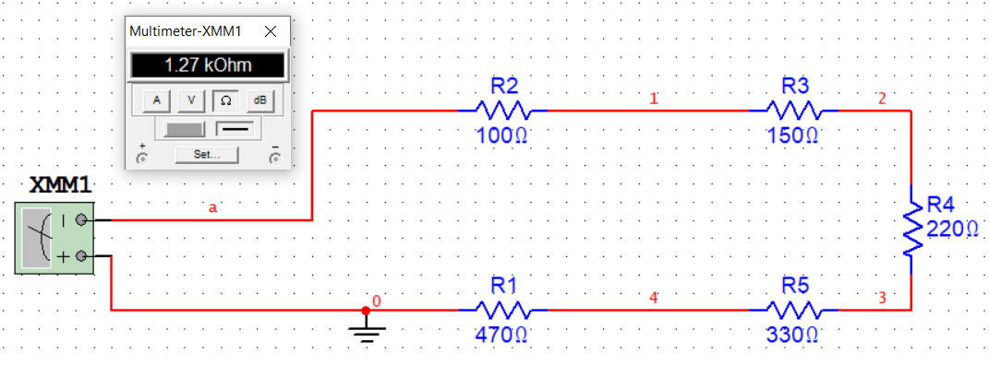

(Measured) Req = 1.27 kΩ Convert k Ω to Ω = 1270 Ω

(Calculated) Req= 1270 Ω

1 ] Details of the calculation (Calculated) Req

Req= 100 Ω + 150 Ω + 220 Ω + 330 Ω + 470 Ω = 1270 Ω

Step 2 : Measurement Current and Voltage

current

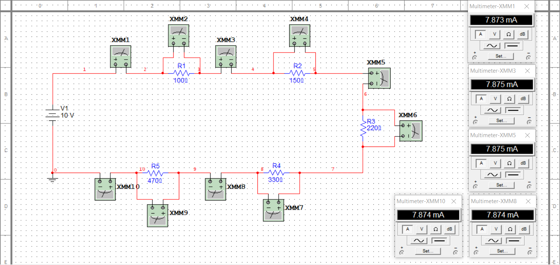

Voltage

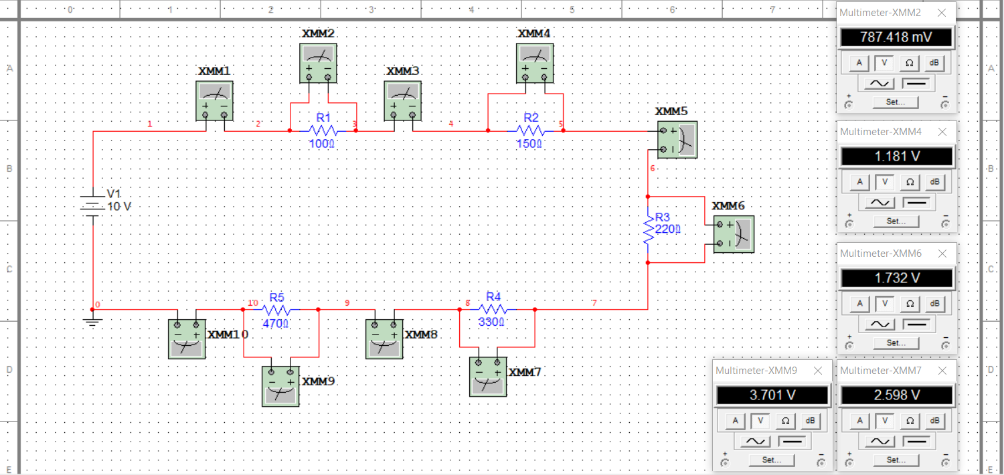

|  |  |  |  |  |  |  |  |  |  |
| --- | --- | --- | --- | --- | --- | --- | --- | --- | --- |
| Iab | Icd | Ief | Ihi | Ijk | Vbc | Vde | Vfg | Vgh | Vij |
| 7.873mA | 7.875mA | 7.875mA | 7.874mA | 7.874mA | 0.97 v | 1.181 | 1.732v | 2.6v | 3.701v |

**2 ] Details of the current calculation ( I )**

Ohm’s law $V=IR$

We can find the current ( I ) ( $i= \frac{Vs}{Req}$)

VS = 10 V and Req = 1270 Ω

$i= \frac{10}{1270}=$ 7.874 $×{10}^{-3}$ A

**3 ] Compare values of current ?**

When comparing the values of current (Iab ) and current (I) we find that they are the same values.

|  |  |  |  |  |  |
| --- | --- | --- | --- | --- | --- |
| Measured | Iab | Icd | Ief | Ihi | Ijk |
| Measured | 7.873mA | 7.875mA | 7.875mA | 7.874mA | 7.874mA |
| Calculated | $$I=\frac{V}{R}$$ | $$I=\frac{V}{R}$$ | $$I=\frac{V}{R}$$ | $$I=\frac{V}{R}$$ | $$I=\frac{V}{R}$$ |
| Calculated | 7.89 mA | 7.88 mA | 7.87 mA | 7.878 mA | 7.875 mA |

**4 ] Compare the current ?**

The measured current and the calculated current almost have the same value

**5 ] What is the relationship between the supply voltage (VS) and the sum obtained?**

**Does it confirm Kirchhoff’s law? Explain.?**

Yes , Kirchhoff’s law is apply

KVL :

Vs = Vbc + Vde + Vfg + Vgh + Vij

Vbc + Vde + Vfg + Vgh + Vij = 0.79 + 1.181 + 1.732 + 2.6 + 3.701 = 10V

Conclusion :

We learned from this experiment that if the resistors in series the current is constant and the voltage is variable and Kirchhoff's law was applied in this experiment to prove that the current is constant and that the total voltage in the circuit is equal to the voltage source